|  |
| --- |
| FULL-STACK PROJECT REPORT  On “Quotes Generator”  Submitted by  ANJALI JAIN  (201500094)  NAINA JOHRI  (201500422)    Department of Computer Engineering & Applications  Institute of Engineering & Technology  GLA University  Mathura- 281406, INDIA |
|  |

2022-2023

Department of computer Engineering and Applications

GLA University, Mathura

17

km. Stone NH#2, Mathura-Delhi Road, P.O. – Chaumuha,

Mathura – 281406



# Declaration

We hereby declare that the work which is being presented in the Mini Project “**Quotes Generator**”, in partial fulfillment of the requirements for Mini Project viva voice, is an authentic record of our own work carried by the team members under the supervision of our mentor Mr. Mandeep Singh.

Group Members:

ANJALI JAIN(201500094)

NAINA JOHRI(201500422)

Course: B.Tech (Computer Science and Engineering)

Year: 3rd

Supervised By:

Mr. Mandeep Singh

Department of computer Engineering and Applications

GLA University, Mathura

17

km. Stone NH#2, Mathura-Delhi Road, P.O. – Chaumuha,

Mathura – 281406



# Certificate

This is to certify that the project entitled “Job Board Website”, carried out in Full-Stack Project, is a bonafide work by Naina Johri, Anjali Jain is submitted in partial fulfillment of the requirements for the award of the degree Bachelor of Technology (Computer Science &Engineering).

_

Supervisor

Mr. Mandeep Singh

Senior Trainer

Depart of CEA, GLA University

# About the Project

This project is a quotes generator, designed to provide users with a collection of inspiring and thought-provoking quotes on a wide range of topics. The generator uses an algorithm to randomly select quotes from a database and display them to the user.

The purpose of this project is to provide a simple and accessible way for users to find and reflect on meaningful quotes. Whether someone is looking for motivation, inspiration, or just a moment of reflection, this generator is designed to offer a diverse range of quotes to suit a variety of needs.

The generator is designed to be user-friendly and easy to navigate, with a simple interface that allows users to easily browse through quotes and share them on social media if they choose. The database of quotes is constantly being updated and expanded, with new quotes added regularly to keep the generator fresh and engaging.

We hope that users find the quotes generated by this project to be both inspiring and thought-provoking, and that the generator serves as a valuable resource for those seeking wisdom and inspiration.

# Motivation

In today's fast-paced world, where people are constantly looking for inspiration and motivation, quotes play a significant role. Quotes are concise expressions of wisdom and inspiration that have the power to uplift and motivate people.

A “quotes generator” is a tool that can generate random quotes based on a specific theme or category. It saves time and effort for individuals who are seeking motivation or inspiration. Moreover, a quotes generator can be a valuable resource for writers, speakers, and educators who need to include inspiring quotes in their work.

With the rapid advancement of technology, a quotes generator can be developed using MERN-STACK. The project aims to develop a quotes generator MERN-STACK using that can generate quotes based on different categories, including motivational, inspirational, love, friendship, and more. The project will utilize various techniques, such as web scraping, natural language processing, and machine learning, to generate accurate and meaningful quotes.

The project aims to create a user-friendly interface that will allow users to easily access and generate quotes based on their preferences. The interface will also allow users to share the generated quotes on social media platforms, such as Twitter and Facebook, which will increase the reach of the quotes and inspire more people.

The project aims to create a tool that will provide easy access to inspirational and motivational quotes, saving time and effort for individuals seeking motivation. It also aims to showcase the power of technology in generating accurate and meaningful quotes using various programming techniques.

# Requirements

1. Software Requirements:
   * Technology Implemented: Full Stack Web Development
   * Languages/Technologies Used: MERN technologies.
   * IDE Used: Visual Studio Code
   * Web Browser: Google Chrome
   * GitHub: GitHub is a code hosting platform for version control and collaboration. It lets you and others work together on projects from anywhere. GitHub Repository: A GitHub repository can be used to store a development project. It can contain folders and any type of files (HTML, CSS, REACT, Documents, Data, Images). A GitHub repository should also include a license file and a README file about the project. A GitHub repository can also be used to store ideas, or any resources that you want to share.
   * Visual Studio Code: Visual Studio Code is a free sourcecode editor made by Microsoft for Windows, Linux and macOS.Features include support for debugging, syntax highlighting, intelligent code completion, snippets, code refactoring, and embedded Git. Users can change the theme, keyboard shortcuts, preferences, and install extensions that add additional functionality. Microsoft has released Visual Studio Code's source code on the VS Code repository of GitHub.com, under the permissive MIT License, while the compiled binaries are freeware.
2. Hardware Requirements:
   * Processor Required: Intel i5
   * Operating System: Windows 10
   * RAM: 8GB
   * Hardware Devices: Computer System
   * Hard Disk

# Acknowledgement

We thank the almighty for giving us the courage and perseverance in completing the project. This project itself is an acknowledgement for all those people who have given us their heartfelt co-operation in making this project a grand success. We extend our sincere thanks to Mr. Mandeep Singh Technical Trainer at “GLA University, Mathura” for providing his valuable guidance at every stage of this project work. We are profoundly grateful towards the unmatched services rendered by him. And last but not least, we would like to express our deep sense of gratitude and earnest thanks giving to our dear parents for their moral support and heartfelt cooperation in doing the main project.

# Abstract

In today's fast-paced world, people are constantly looking for inspiration and motivation to help them overcome challenges and achieve their goals. Quotes, being concise expressions of wisdom and inspiration, are a valuable source of motivation for many individuals. However, finding the right quote for a particular situation or mood can be a time-consuming task. Therefore, the project aims to develop a quotes generator using Python programming language that can generate accurate and meaningful quotes based on different categories, such as motivational, inspirational, love, friendship, and more.

The project utilizes various programming techniques, including web scraping, natural language processing, and machine learning, to generate quotes that are both accurate and meaningful. The generated quotes are stored in a database and can be accessed through a user-friendly interface that allows users to generate quotes based on their preferences. The interface also allows users to share the generated quotes on social media platforms, such as Twitter and Facebook.

The project's main objective is to create a tool that provides easy access to inspirational and motivational quotes, saving time and effort for individuals seeking motivation. The project also showcases the power of technology in generating accurate and meaningful quotes using various programming techniques.

Overall, the quotes generator project is an innovative approach to providing individuals with easy access to motivational and inspirational quotes, utilizing modern programming techniques to generate accurate and meaningful quotes. The project has the potential to inspire and motivate a large number of people, and it can serve as a valuable resource for writers, speakers, and educators who need to include inspiring quotes in their work.

# Contents

1. Introduction:

Introduction to MERN STACK.......…......

Pre-requisites………………………

1. Technologies Used:

Front-end……………………………….

Back-end……………………………….

1. List of Figures............................................................ 20-26
2. Software Testing...................................................................... 27-
3. Conclusion..................................................................... 32
4. Bibliography.................................................................. 33

Technology Used

HTML

HTML stands for Hyper Text Markup Language. It is used to design web pages using the markup language. HTML is the combination of Hypertext and Markup language. Hypertext defines the link between the web pages and markup language defines the text document within the tag that define the structure of web pages. HTML is used to create the structure of web pages that are displayed on the World Wide Web (www). It contains Tags and Attributes that are used to design the web pages. Also, we can link multiple pages using Hyperlinks. The basic structure of an HTML page is laid out below. It contains the essential building-block elements (i.e., doctype declaration, HTML, head, title, and body elements) upon which all web pages are created. The basic structure of an HTML page is laid out below. It contains the essential building-block elements (i.e., doctype declaration, HTML, head, title, and body elements) upon which all web pages are created.

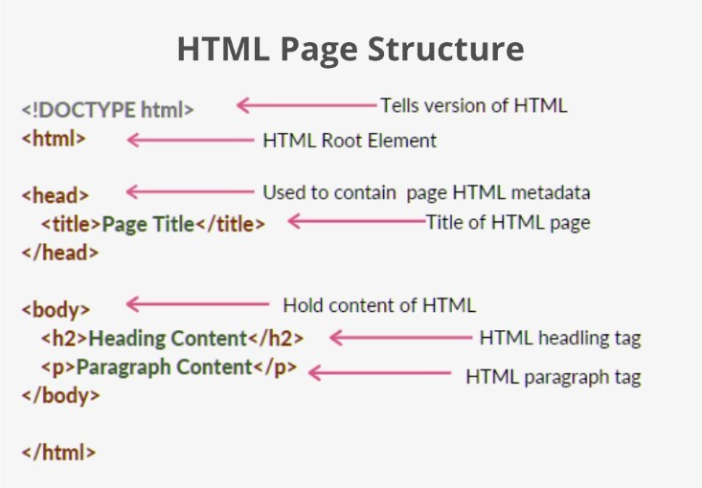

CSS5

CSS is the language we use to style an HTML document. CSS describes

how HTML elements should be displayed. CSS stands for Cascading style sheets. It describes how HTML elements are to be displayed on screen ,paper, or the other media. CSS saves a lot of work It can control the layout of the multiple web pages all at once. External stylesheet are stored in CSS files.CSS file extension name is “.css” .CSS is used along with HTML and JavaScript in most website to create user interface for web application and user interfaces for many mobile application.

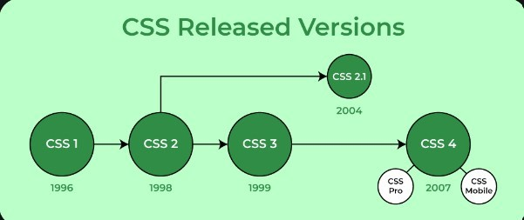

REACT

React is a popular JavaScript library for building user interfaces. It allows developers to create reusable UI components and efficiently manage the state of their applications. React Image is a component that can be used in React applications to display images. React Image provides an easy way to display images with advanced features such as lazy loading, placeholders, and error handling. It also supports different types of image sources, including local files, remote URLs, and base64-encoded data.

MONGODB

MongoDB is a popular open-source NoSQL database management system that stores data in a document-oriented data model. Unlike traditional relational databases, MongoDB does not use tables, rows, and columns to store data. Instead, it stores data as documents in a flexible and scalable JSON-like format called BSON (Binary JSON).MongoDB allows developers to work with unstructured and semi-structured data, making it ideal for handling data with varying formats and structures. It supports various data types, including strings, numbers, dates, arrays, and objects, and provides powerful querying and indexing capabilities. MongoDB also supports horizontal scalability, allowing developers to scale their databases by adding more servers to handle increased traffic or data volumes. It supports sharding, which distributes data across multiple servers, and replica sets, which provide automatic failover and data redundancy.

List Of Figures:

HOME PAGE:

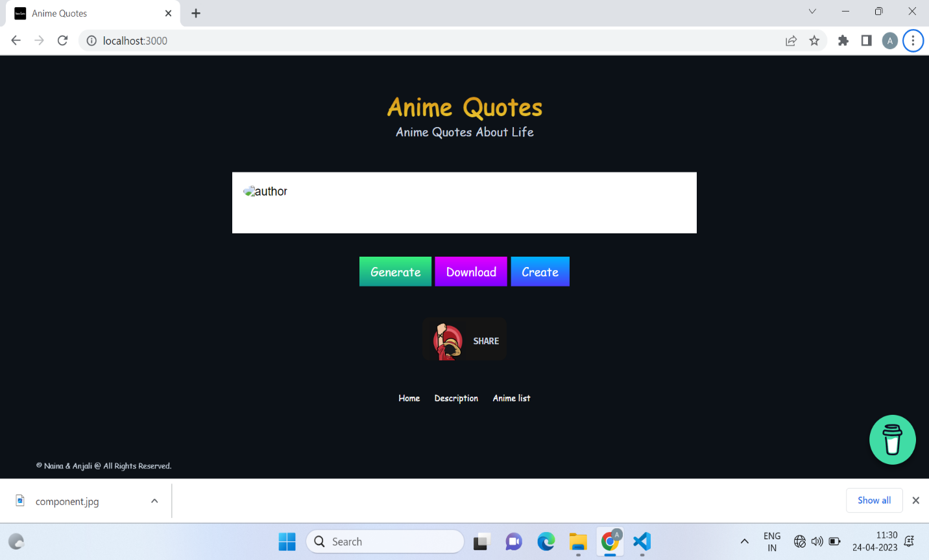

Description Page:

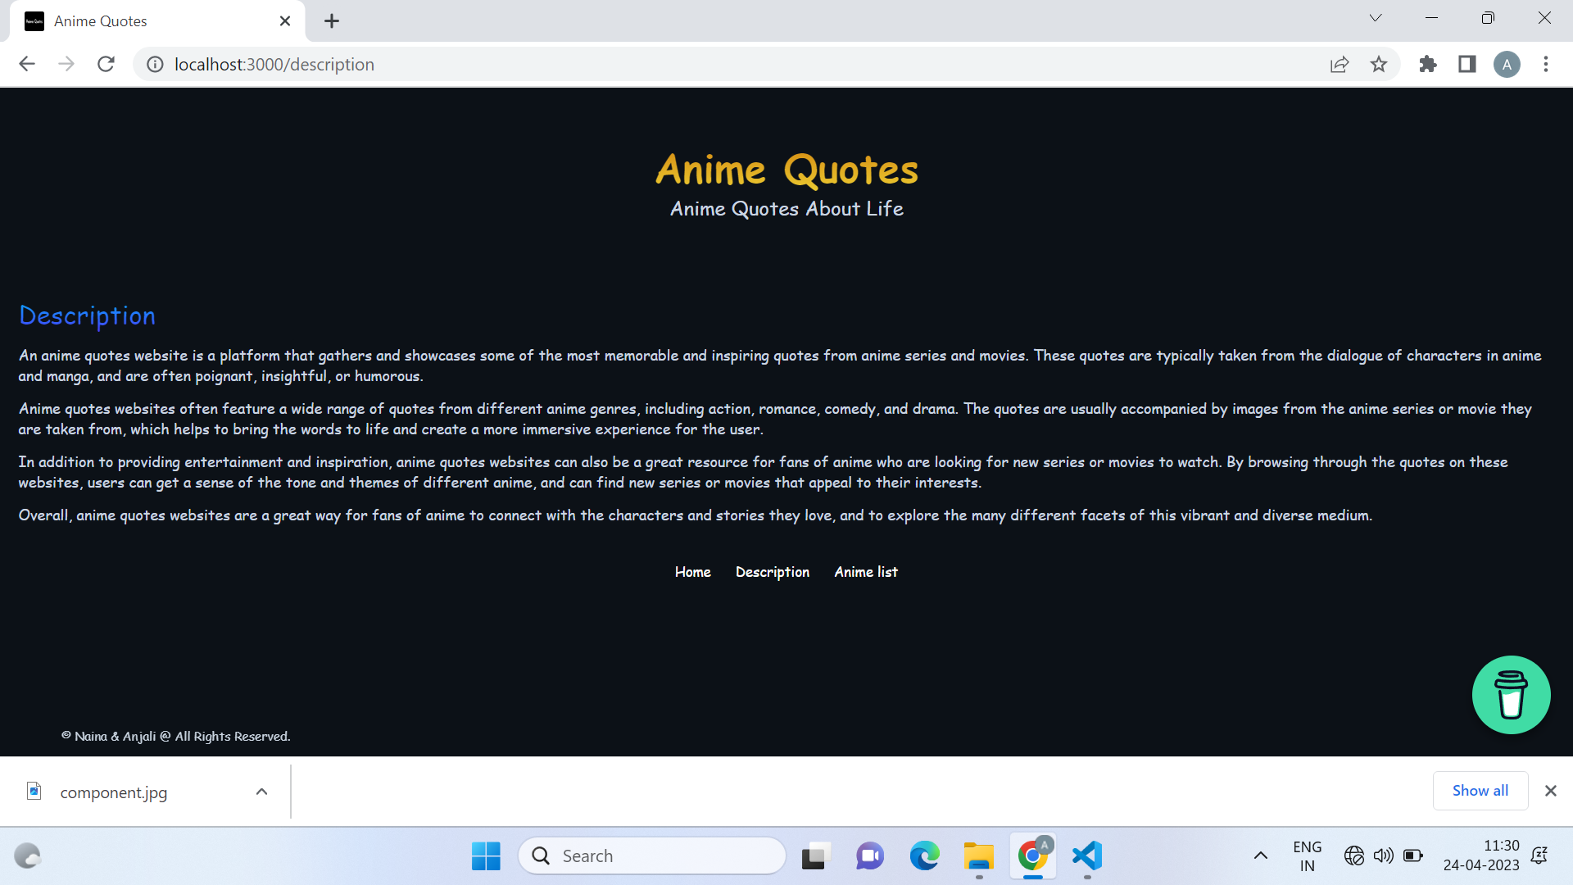

Anime Quotes Page:

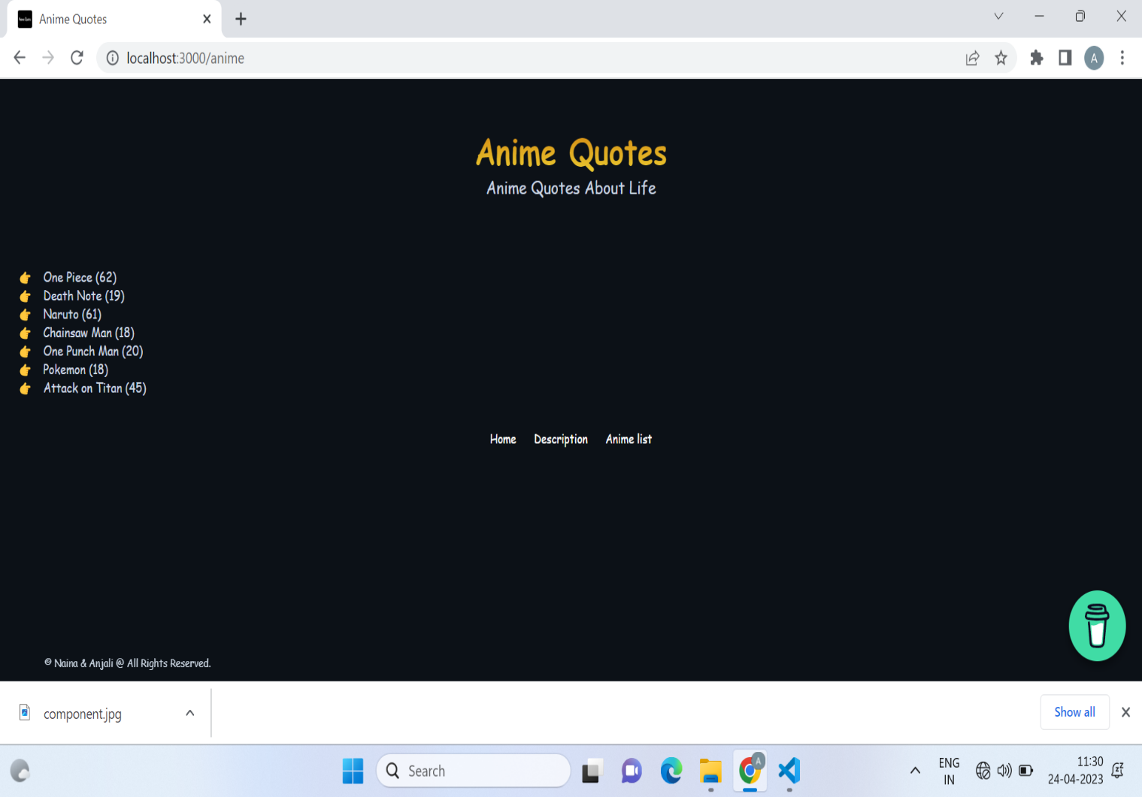

Bibliography

* www.javatpoint.com
* www.geekforgeeks.com
* www.w3schools.com

Books:

* Web design with MERN STACK
* Full Stack Using Scripting Technologies

Faculty Guidelines:

Mr. Mandeep Singh (Technical Trainer of GLA University)